TurnQuest Everest Insurance Suite
General Insurance System(GIS)
Setups User Manual



01st September 2014

Contents
1. GENERAL PARAMETERS SETUP
2. CLASS SETUPS
2.1 Creating Classes
2.2 Creating Subclasses
3. PRODUCT SETUPS
3.1 Defining a Product
3.2 Attaching Subclasses to Products
4. CLAUSES SETUPS
4.1 Creating Clauses
4.2 Attaching A Clause To A Subclass
5. TAXES SETUPS
5.1 Setting Up Tax Rates Not Based on Subclasses
6. SCHEDULES SETUPS
7. COVER TYPES AND SECTIONS
8. VEHICLE MAKES SETUP
9. PERILS AND TERRITORIES
9.1 Defining a New Peril
9.2 Defining Territories
9.3 Defining Quake Zones
10. PREMIUM RATES SETUP
10.1 Setting Up Premium Rates for Subclass Binders
10.2 Defining Subclass Premium Bands

TURNQUEST GIS SETUPS MANUAL
To access the setup menu screen, click the ‘Setups’ link on the home page
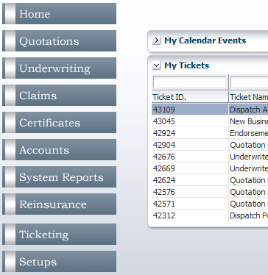

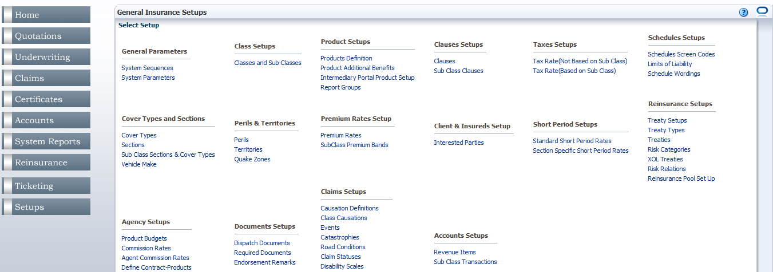

GENERAL PARAMETERS SETUP

CLASS SETUPS
This setup section is where the various classes of business and their subclasses are set up. Click on the ‘Classes and Sub Classes’ link in the ‘Class Setups’ section on the setup menu.
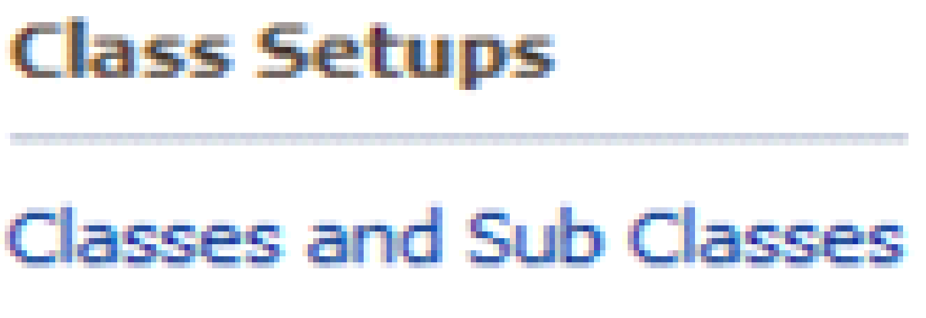
Clicking the 'Class and Sub Classes' brings you to the 'Classes and SubClasses Definition' screen
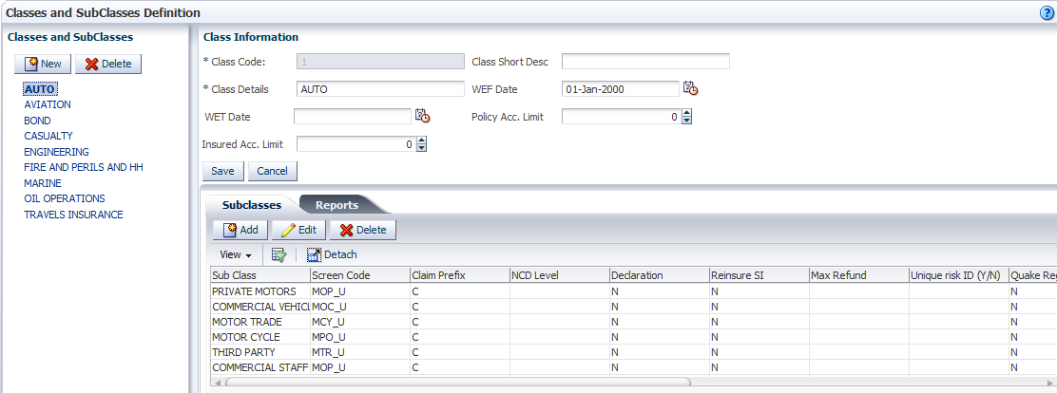
The items listed on the left pane of the screen are the various classes of business that the company provides cover for. Selecting an item on the list of classes on the ‘Classes and Subclasses’ pane on the left populates the fields on the ‘Class Information’ pane to the right with details of the selected class.
The ‘Class Information’ panel at the top shows details of the class of business that has been selected.
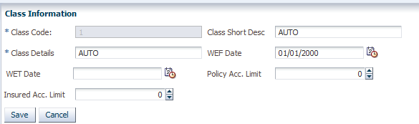
- The ‘Class Code’ is a system-generated identifier for the class
- The ‘Class Details’ field is populated with the name of the class as it will appear on the list of classes on the left pane.
- ‘Class Short Desc’ is a short description of the class of business
- The ‘WEF Date’ is the ‘With Effect from date from which the class of business is made available for business in the system and the ‘WET (With Effect To) Date’ is the date up to when the class can be used in the system.
: The ‘WET Date’ is not a mandatory field and may be left blank so as to avoid putting a limit on the availability of the class.
- The ‘Policy Acc. (Accumulation) Limit’ is the maximum premium for any one policy in this class of business
- The ‘Insured Acc. (Accumulation) Limit’ is the maximum premium for any one insured in this class of business
On the panel below the ‘Class Information’ pane, there are the ‘Subclasses’ and ‘Reports’ tabs. The ‘Subclasses’ tab shows the subclasses that have been created and attached to the selected class.
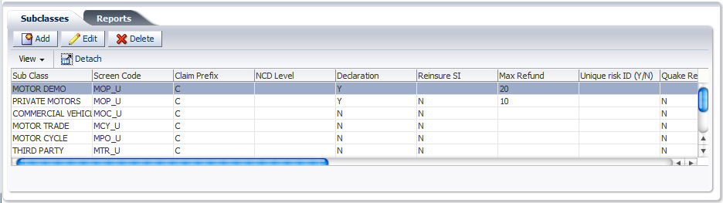

The reports tab shows links for printing tasks for reporting purposes.
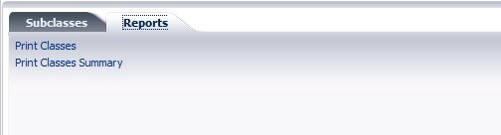

- Creating Classes
- On the ‘Classes and Sub Classes’ pane to the left, click  to clear the fields on the 'Class Information' pane on the right to create a new class.
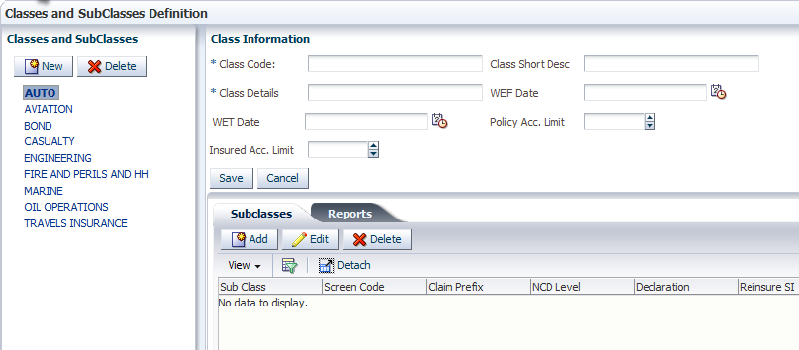
- Fill in the necessary details for the class information and click  to save/create a new class.

- Creating Subclasses
- On the 'Classes and Sub Classes' pane, select an existing class.

The fields in the 'Class Information' pane are populated with the details of the selected class.
The 'Subclasses' tab in the lower pane shows the Subclasses that have been created under the selected class.
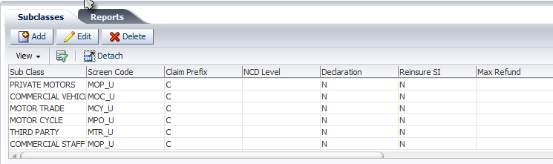
- Select the 'Sub Class' tab in the lower panel below the ‘Class Information’ pane and click

The 'Sub Class Information' dialog box is generated.

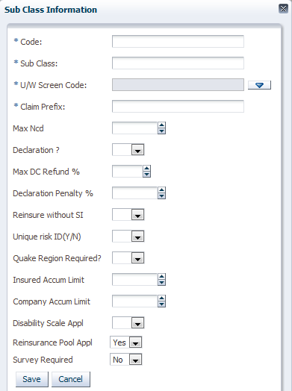

- Populate the fields with the appropriate details
- The ‘Code’ field uniquely identifies each subclass under the selected class.
- The ‘Sub Class’ field should contain the name to be given to the subclass.
- To populate the ‘U/W Screen Code’ field, click  to bring up the ‘Underwriting Screen List’ dialog box.

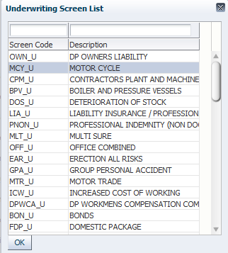
- Select an item from the list and click to populate the ‘U/W Screen Code’ field.
: The list contains screen codes that have been set up in ‘Schedules Screen Codes’ under the ‘Schedules Setup’ section on the setup menu.
- Claim prefix is a prefix is a prefix that appears as the first character in the claim number for the class
- The ‘Max NCD?’ specifies the maximum number of years that NCD can be applied. NCD is a discount a client is entitled to when his policy has no claims. There are NCD 1,2,3,4 and 5. NCD 1 is applied when a client has no claims for over a year. NCD 2 is applied when a client has no claims for over 2 years and so on.
- The ‘Declaration?’ field specifies whether the subclass allows declaration endorsements. Click 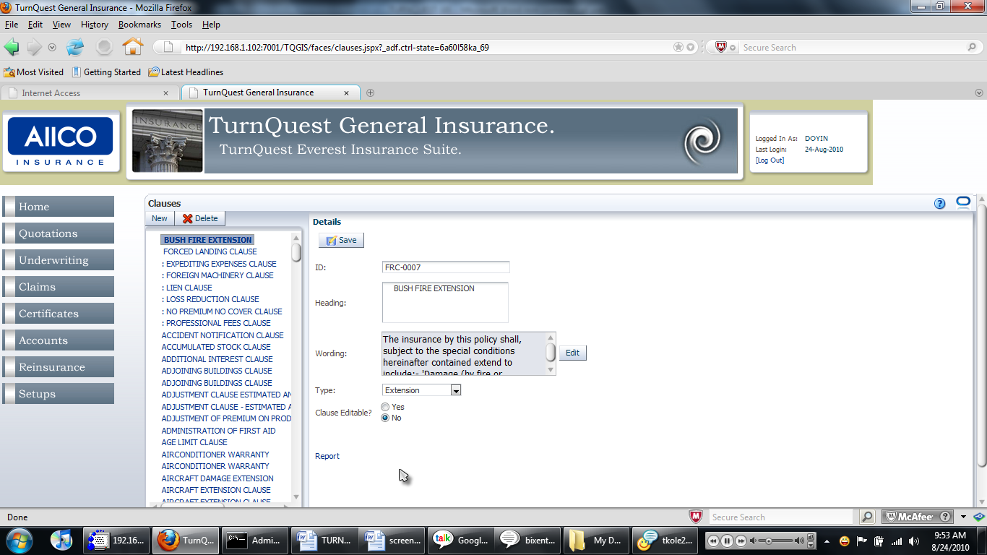 and choose ‘Yes’ or ‘No’ from the LOV (list of values).
- The ‘Max DC Refund?’ field specifies the maximum declaration refund that can be paid on a policy; it’s a percentage of the premium.
- The ‘Reinsure Without SI’ field specifies whether the subclass can allow reinsurance without sum insured. Click and choose ‘Yes’ or ‘No’ from the LOV.
- The ‘Unique risk ID(Y/N)’ field specifies whether the risk IDs specified for the risks in a policy are unique and cannot be duplicated so that no two risks have the same ID.
- The ‘Quake Region Required?’ field specifies whether a quake region is required when using this subclass. Click and choose ‘Yes’ or ‘No’ from the LOV.
- The ‘Insured Accum Limit’ is the maximum premium for any insured in this subclass.
- The ‘Company Accum Limit’ is the maximum premium for any one policy in this subclass.
- The ‘Disability Scale Appl’ field specifies whether disability scale can be used with the subclass. Disability scale is a rate applied for injury to a specific body part. For example, head injury = 10%, finger injury = 5% etc. Workmen compensation and group personal accident use this.
- The ‘Reinsurance Pool Appl’ field specifies whether reinsurance pool is applicable. Reinsurance pool is a contribution made by various insurance companies in order to cater for an enormous claim for a particular product e.g. Aviation insurance. Click and choose ‘Yes’ or ‘No’ from the LOV.
- The ‘Survey Required’ field specifies whether a survey is required.
- Click 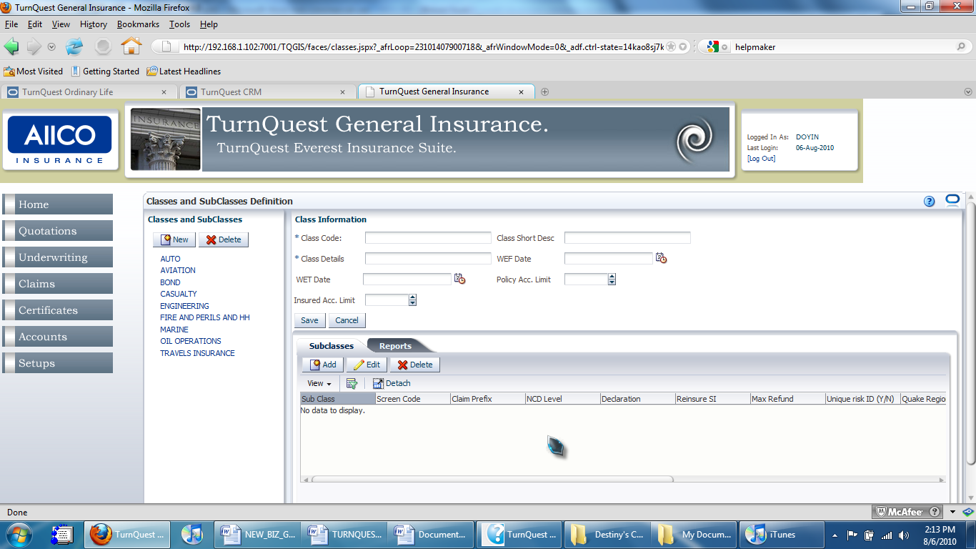 to save the record of the new Subclass.
- To edit an existing subclass, select it and click  to edit the subclass details.

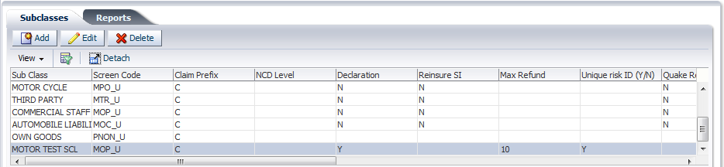
The ‘Sub Class Information’ dialog box is generated.
- Click  on the dialog box after filling in the necessary fields to update the record.
- Click to delete an existing Subclass record.
: To make a subclass available for use at underwriting, premium rates have to be setup for it and sections and cover types should also be attached to it.

PRODUCT SETUPS
This section of the core setup is where products to be used in underwriting and quotations are set up. Product setup screens are accessed from the ‘Product Setups’ section on the setup menu.
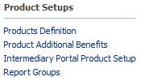
- Defining a Product
- Click on the ‘Product Definitions’ link in the ‘Product Setups’ section on the core setup menu. This brings up the ‘Product Definition’ screen.
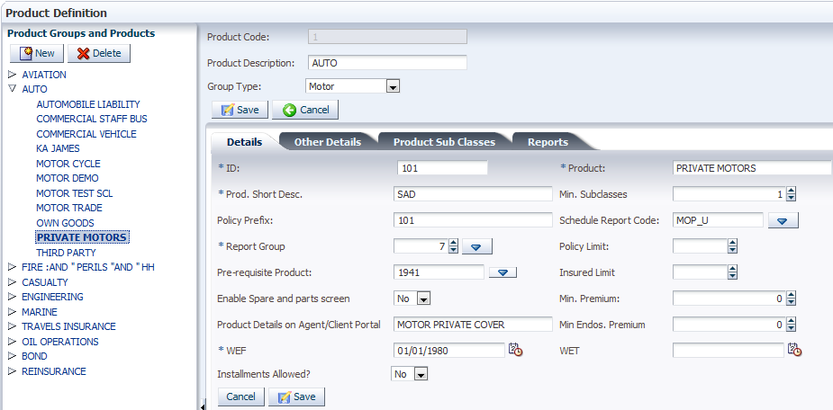
Selecting a product group from the list on the ‘Product Groups and Products’ pane lets you view the details on several tabs on the pane to the right.
: On the ‘Product Groups and Products’ pane, the existing product groups are listed. Click on the arrowhead beside a product group to expand it and view the list of products under that product group.
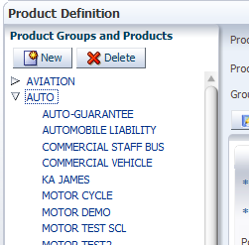

Selecting a product lets you view its details in the various tabs on the pane to the right
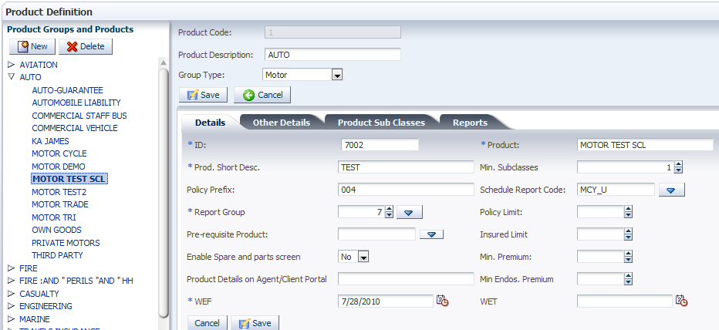
: On the pane to the right, the details in the upper block are for the product group while those below are for the product.

- Click on the left pane to create a product or product group. This brings up a dialog box for selecting which item to create
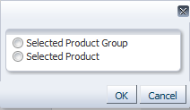
- Click the ‘Selected Product Group’ or ‘Selected Product’ radio button to choose whether to create a new product group or a new product respectively.
- Click and fill in the details under the ‘Details’ tab.
: If the ‘Selected Product Group’ radio button is selected, all the fields on the pane to the right are cleared. If the ‘Selected Product’ radio button is selected, only the fields on the lower block are cleared and those in the upper block are unchanged to show that the product will be created under the same product group that has been selected. To create a product, a product group has to be selected before clicking and checking the ‘Selected Product Group’ radio button

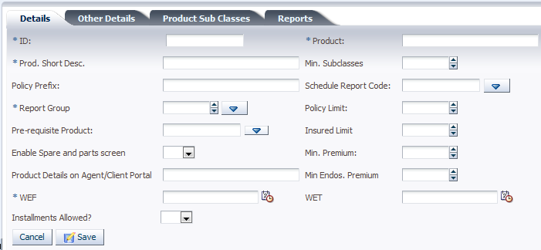

- The ‘ID’ field specifies a unique identifier for the product.
- The ‘Product’ field specifies the name of the product as it appears on the product list.
- The ‘Prod. Short Desc.’ shows a short description of the product.
- The ‘Min. Subclasses’ field specifies the minimum number of subclasses that can be attached to the product.
- The ‘Policy Prefix’ field specifies the prefix to the policy number of any policy done on the product.
- The ‘Schedule Report Code’ field specifies the screen code for the schedule to be used for the product.
- The ‘Report Group’ field specifies the report group to which the product will belong for reporting purposes.
- The ‘Pre-requisite Product’ field specifies the pre-requisite product that has to be added to a policy before this product can be added.
- The ‘Min. Premium’ field specifies the minimum premium that the policy must yield to include this product.
- The ‘Min Endos. Premium’ field specifies the minimum endorsement premium that the policy must yield to include this product.
- The ‘WEF’ and ‘WET’ (‘With Effect From’ and ‘With Effect To’) dates specify the validity period for the product.
- Click on the ‘Other Details’ tab to input further details

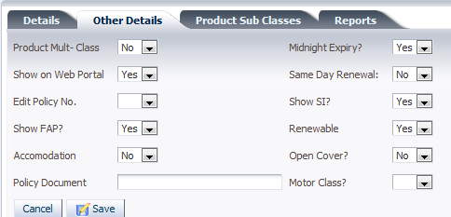

- The ‘Product Multi-Class’ field specifies whether more than one subclass can be added to the product. Click to select ‘Yes’ or ‘No’.
- The ‘Midnight Expiry?’ field specifies whether the cover period will end at midnight on the last day of cover. Click to select ‘Yes’ or ‘No’
- The ‘Same Day Renewal’ field specifies whether the policy can be renewed on the same day that the cover period ends. Click to select ‘Yes’ or ‘No’
- The ‘Edit Policy No’ field specifies whether the policy number generated for the product can be edited. Click to select ‘Yes’ or ‘No’
- The ‘Show SI?’ field specifies whether the sum insured will be displayed in underwriting. Click to select ‘Yes’ or ‘No’
- The ‘Show FAP?’ field specifies whether the future annual premium will be displayed in underwriting. Click to select ‘Yes’ or ‘No’
- The ‘Renewable’ field specifies whether the policies underwritten with this product can be renewed. Click to select ‘Yes’ or ‘No’
- The ‘Open Cover’ field specifies whether the product can be used in underwriting open cover policies. Click to select ‘Yes’ or ‘No’
- The ‘Motor Class’ field specifies whether the product is from the motor class of business. Click to select ‘Yes’ or ‘No’

- Attaching Subclasses to Products
It is necessary to define what classes of business the product will be used in underwriting and attaching subclasses to each product accomplishes that.
- Select the ‘Product Sub Classes’ tab after selecting a product on the ‘Product Definition’ screen.
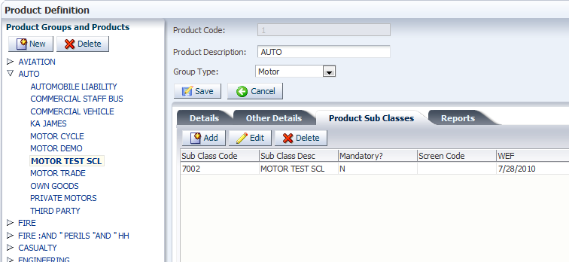

- Click to bring up the ‘Product Sub Class Information’ dialog box
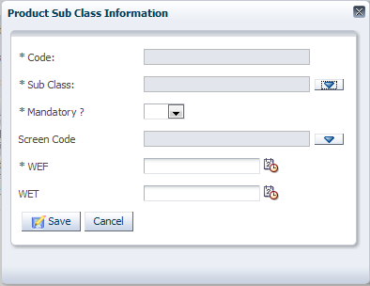
- Populate the fields on the dialog box
- The ‘Code’ field is auto populated depending on the selected subclass.
- Click  to bring up the ‘Select A Sub Class’ dialog box and select a subclass from the list. Click 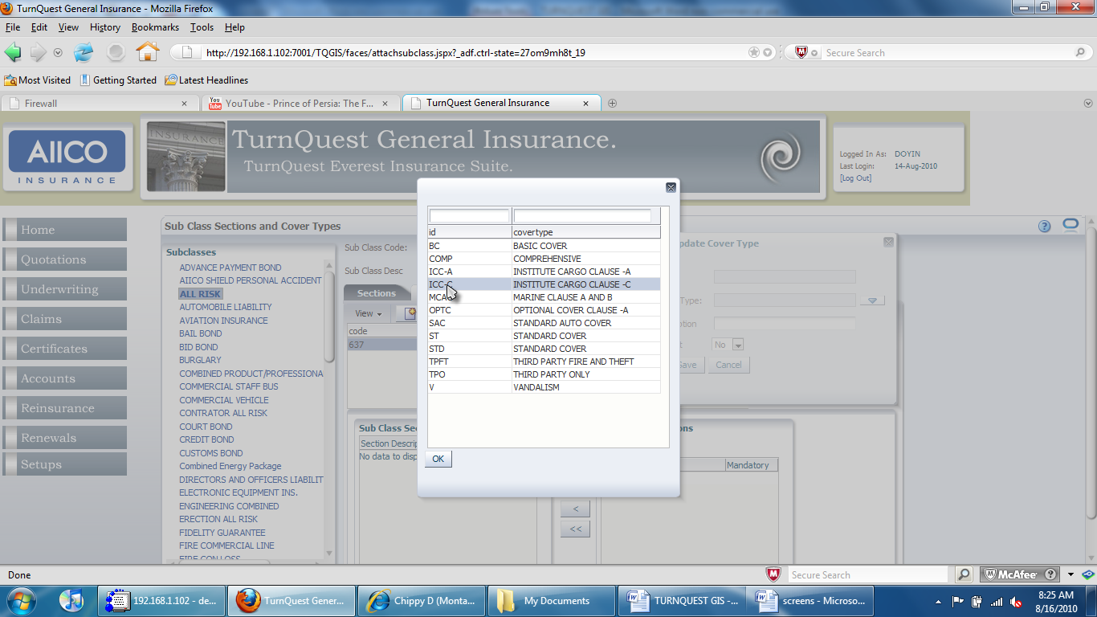 to populate the ‘Sub Class’ field.
- The ‘Mandatory?’ field specifies whether selecting the subclass is mandatory when using the product. Click and choose ‘Yes’ or ‘No’ from the LOV.
- Click to bring up the list of screen codes, select the appropriate one and click to populate the ‘Screen Code’ field.
: To edit the details of an attached subclass, select the subclass and click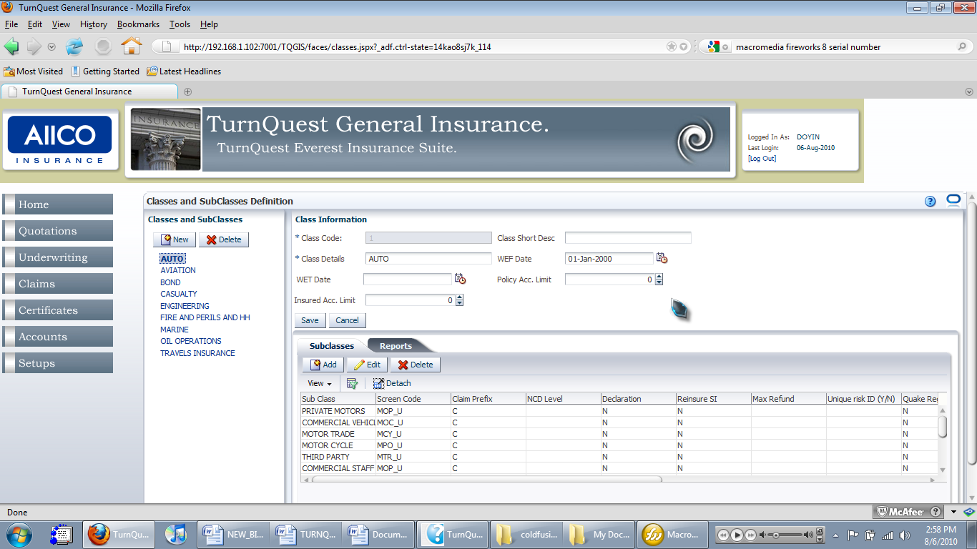. This brings up the ‘Product Sub Class Information’ dialog box again. Change the details as desired and click 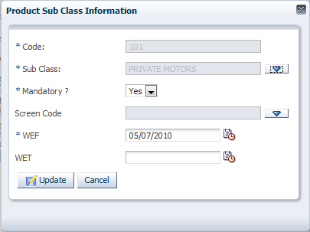 to save the changes.

CLAUSES SETUPS
This setup is necessary for defining clauses to be used in the business. After clauses are defined, they are to be attached to the respective subclasses they are to be used with. The setup screens are accessed from the ‘Clauses Setups’ section on the setup menu.
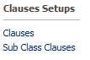
- Creating Clauses
- On the setup menu, under the ‘Clauses Setups’ section, click ‘Clauses’. This brings up the ‘Clauses’ screen.
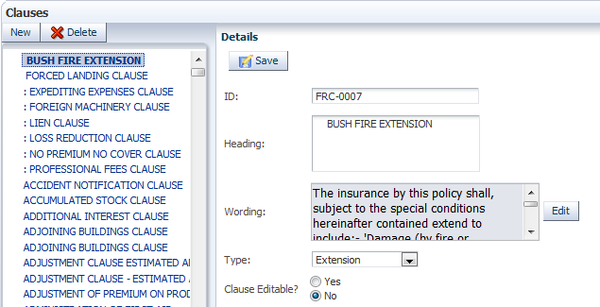
On the left pane is a list of existing clauses and on the ‘Details’ pane to the right are fields which show details for any selected item on the list.
- To create a new clause, click on the left pane. This clears the fields on the ‘Details’ pane for new entries.
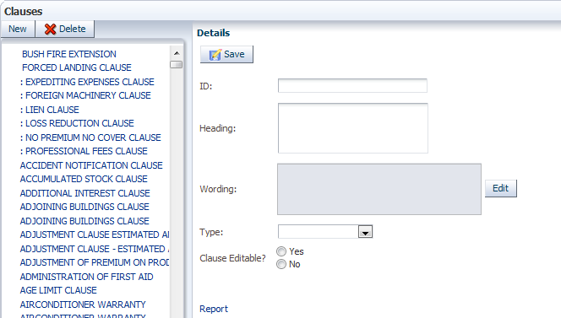
- Fill the following fields appropriately.
- The ‘ID’ field contains a short alphanumeric code to identify the clause.
- The ‘Heading’ field contains the full name of the clause.
- For the ‘Wording’ field, click to generate the ‘Add/Update Clause Details’ text box to type in the text body of the clause.
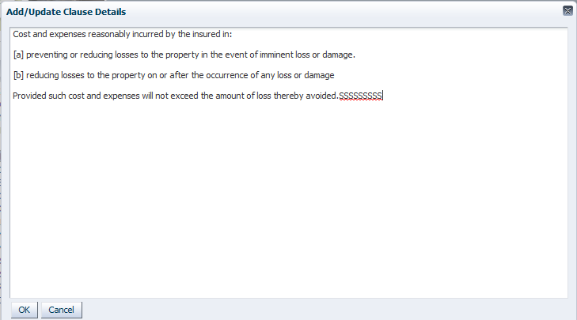
- Click when finished editing the text to populate the ‘Wording’ field on the ‘Details’ pane. On the ‘Type’ field, click to bring generate the drop-down list of clause types and make a selection to populate that field.
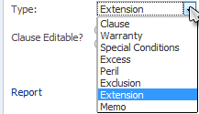

- Click the ‘Yes’ or ‘No’ radio button to define whether the clause is editable or not.
- Click to save all entries and create the new clause.

- Attaching A Clause To A Subclass
- On the setup menu, click ‘Sub Class Clauses’. This brings up the ‘Sub Class Clauses’ screen.

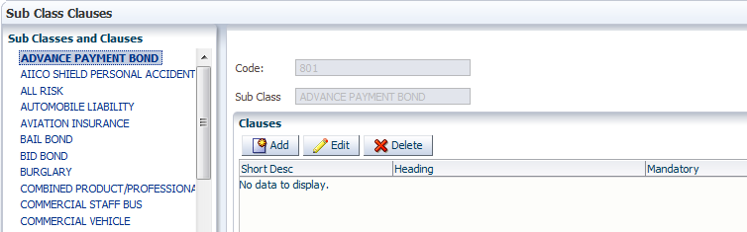

As shown, selecting an item on the ‘Sub Classes and Clauses’ pane populates the fields on the right pane with details of the selected subclass. This list contains already created subclasses.
- Click on the ‘Clauses’ pane to add a clause to the selected subclass. This brings up the ‘Sub Class Information’ dialog box.

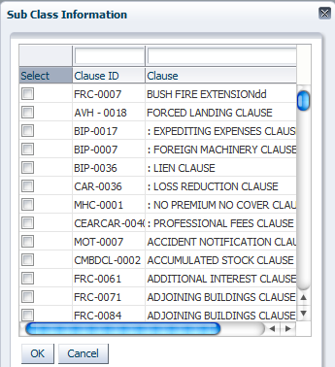

- Select a clause or multiple clauses using the checkboxes and click to add the selected clause(s) to the list of clauses.
- To edit a clause on the list of added clauses, select the desired clause and click. This brings up the ‘Edit Sub Class’ clause dialog box.

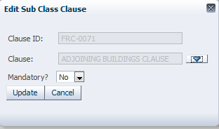
- Click on the ‘Clause’ field to bring up the ‘Sub Class Information’ dialog box.
- Select a new clause and click to populate the field.
- Click and select ‘Yes’ or ‘No’ to choose whether to make the clause mandatory.
- Click to make the changes to the selected subclass clause.

TAXES SETUPS
Tax rates applied in transactions executed in the system. The setup screens are accessed from the ‘Taxes Setups’ section on the setup menu.
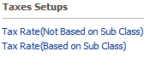

Setting Up Tax Rates Not Based on Subclasses
- Click on the ‘Tax Rate (Not Based on Sub Class)’ link in the ‘Taxes Setups’ section on the setup menu. This brings up the ‘Tax Rates’ screen.
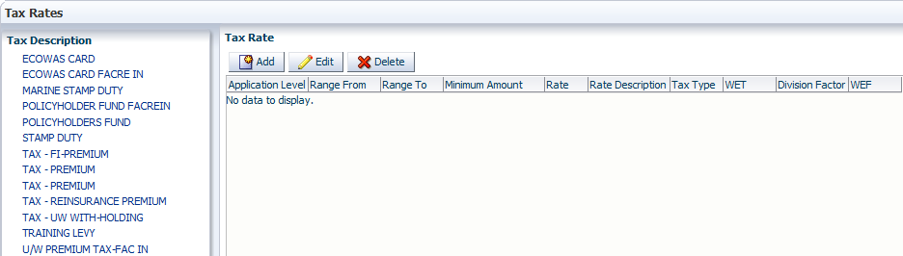
- To define a tax rate, select a tax type from the list on the ‘Tax Description’ pane and click. This brings up the ‘Add/Edit Tax Rate’ dialog box
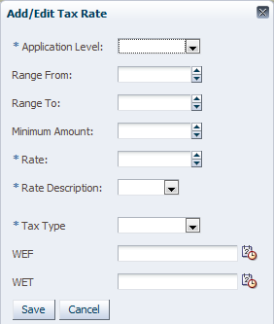
- The ‘Application Level’ field specifies the level of business where the tax rate will be applied. Click and select from the drop-down list to specify
- The ‘Range From’ and ‘Range To’ fields specify a range of

SCHEDULES SETUPS
The policy schedules screens are setup in this section. These allow for comprehensive risk detail input in underwriting.
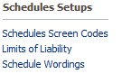

- Setting Up Schedule Screens
- Click on the ‘Schedules Screen Codes’ link in the ‘Schedules Setups’ section on the setup menu. This brings up the ‘Screen Codes’ screen.

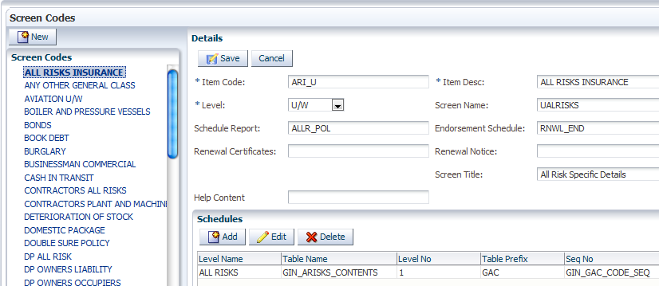
Selecting an item on the list of screen codes on the left populates the fields on the ‘Details’ pane to the right.
- The ‘Item Code’ field specifies a distinct code to identify the screen code.
- The ‘Level’ field specifies the level at which the screen code can be used. Click and select an item from the LOV (list of values).
- The ‘Schedule Report’ field shows a technical report code
- The ‘Renewal Certificates’ field shows a technical code specified for the renewal certificate for the product.
- The ‘Item Desc’ field contains a brief description of the screen code as it appears on the screen codes list
- Click on to clear the fields on the ‘Details’ pane.
- Fill in the appropriate details and click 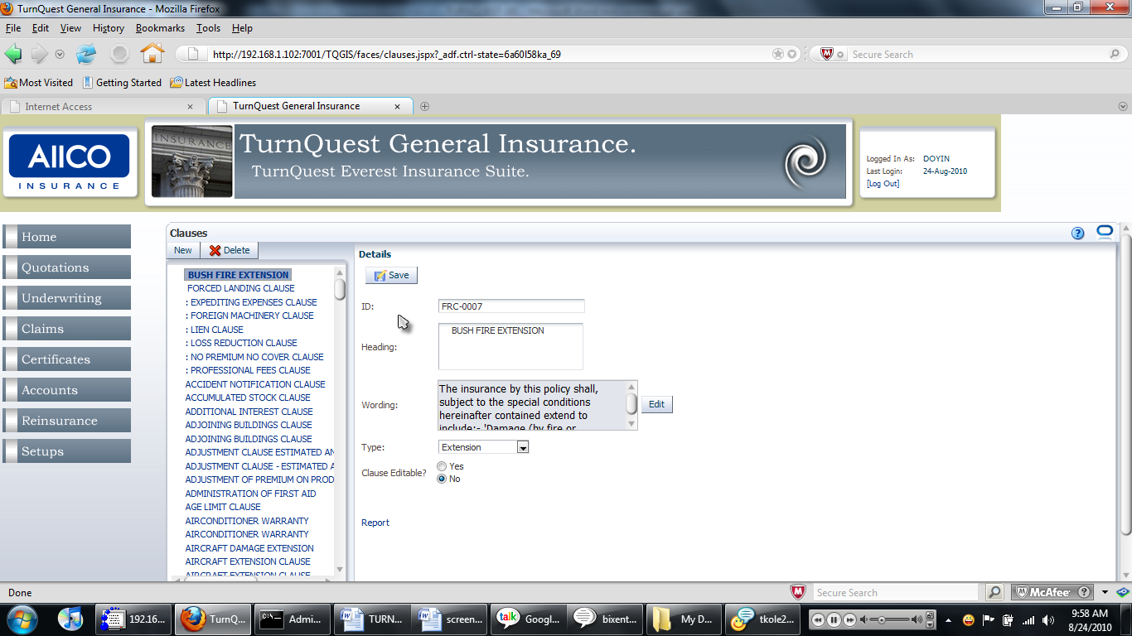 to save the details of the new schedule.
: The ‘Schedules’ pane in the lower right part of the setup screen contains database-specific details and should only be altered by a user with technical know-how of the backend of the system.

- Setting up Schedule Wordings
- Click on the ‘Schedule Wordings’ link in the ‘Schedules Setups’ section on the setup menu. This brings up the ‘Schedule Wordings’ screen.
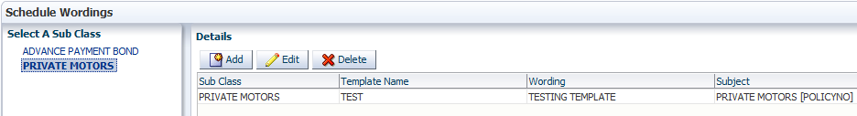
- Click to bring up the dialog box for inputting schedule wording details.
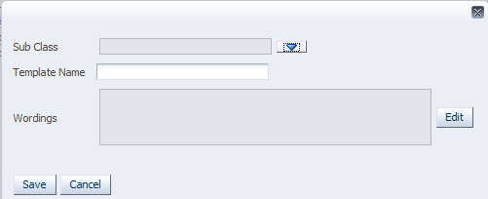
- The ‘Sub Class’ field should contain the subclass that the schedule is to be used for. Click to bring up the ‘Select Sub Class’ dialog box.
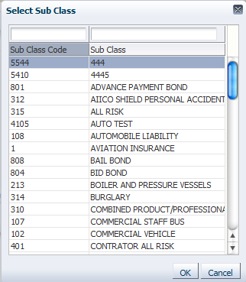
- Select a subclass and click to populate the ‘Sub Class’ field.

- The ‘Template Name’ field contains a name to be given to the schedule.
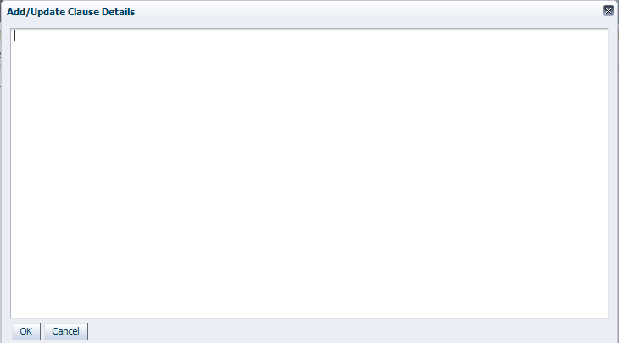
- The ‘Wordings’ field contains the actual literature for the schedule. Click 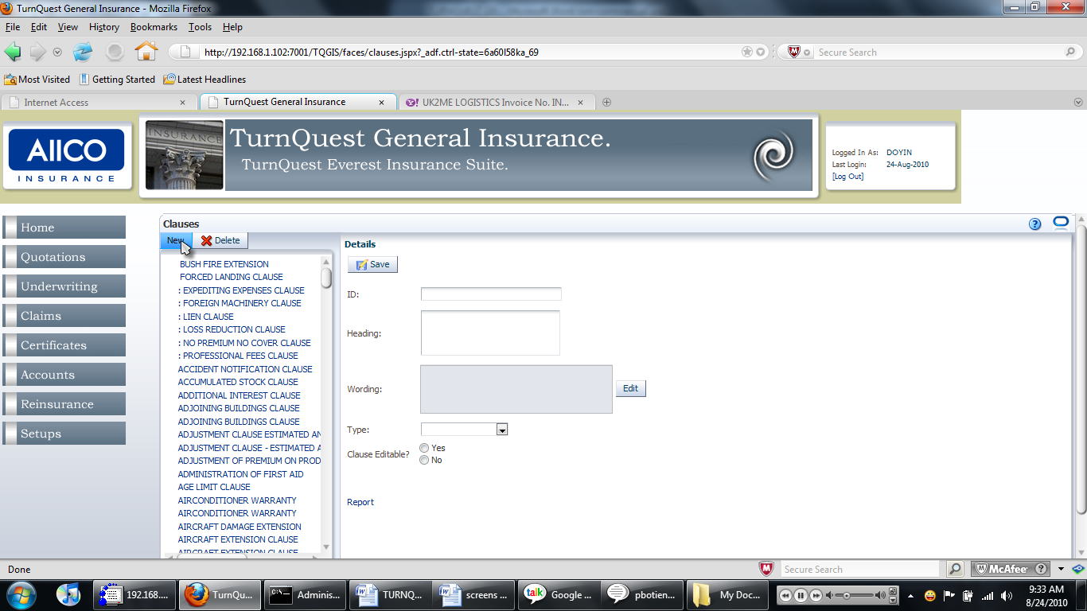 to bring up the ‘Add/Update Clause Details
Type in the wordings for the clause and click to save the wordings and populate the ‘Wordings’ field.

- Click to save the schedule record.
: The ‘Select A Sub Class’ pane shows a list of subclasses for which schedule wordings have been set up. Selecting an item generates the schedule that has been set up for the selected subclass on the ‘Details’ pane. To edit a schedule, click to bring up the dialog box and then click 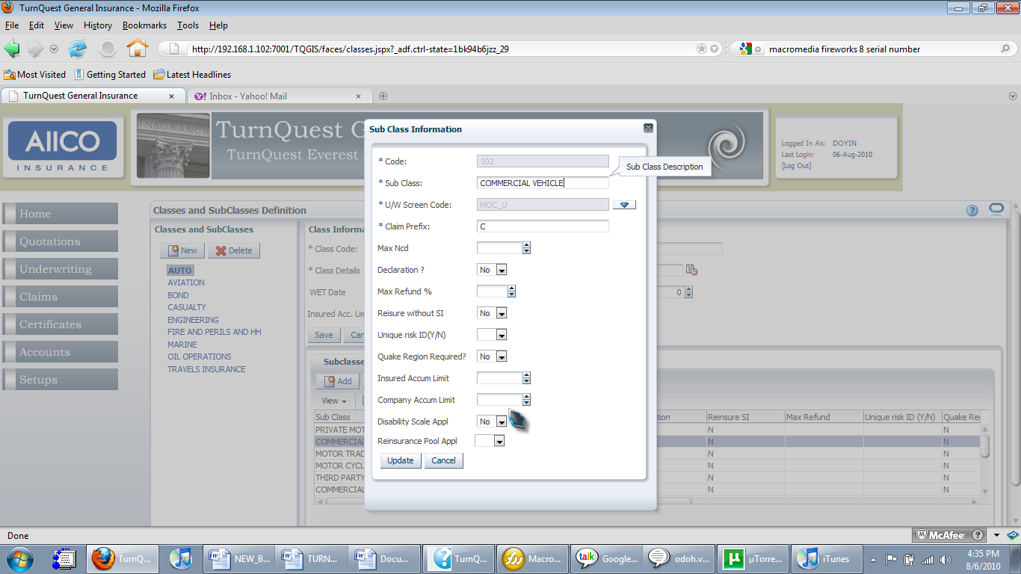 to save the new details. Click to delete a set up schedule.

COVER TYPES AND SECTIONS
This section gives a walkthrough for creating cover types and sections and attaching them to subclasses.
The cover types and sections setup is accessed from the ‘Cover Types and Sections’ section on the setup menu.
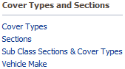

- Creating Cover Types
- Click the ‘Cover Types’ link in the ‘Cover Types and Sections’ section on the setup menu. This brings up the ‘Cover Types’ screen
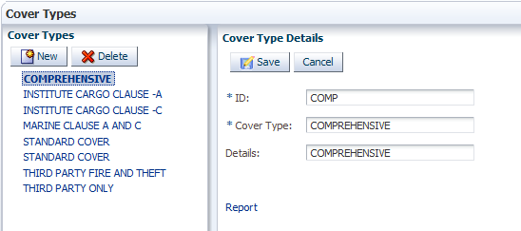
: Selecting an existing cover type lets you view its details on the ‘Cover Type Details’ pane to the right.
- Click to clear the fields on the ‘Cover Type Details’ pane and fill in the necessary details to create a new cover type.
- The ‘ID’ field specifies a unique identifier for the cover type.
- The ‘Cover Type’ field specifies the name of the cover type as it is to be seen on the list.
- The ‘Details’ field contains a description of the cover type.
- Click to save the new cover type.

- Creating Sections
- Click the ‘Sections’ link in the ‘Cover Types and Sections’ section on the setup menu. This brings up the ‘Sections’ screen

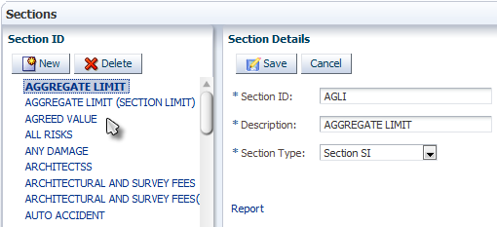
: Selecting an item on the list on the ‘Section ID’ pane on the left side of the screen lets you view its details on the ‘Section Details’ pane to the right.
- Click to clear the details fields and fill in details for a new section ID item.
- The ‘Section ID’ field specifies the identifier for the section to be created.
- The ‘Description’ field specifies the name of the section as it is to be seen on the list.
- The ‘Section Type’ field is populated by choosing an option from the drop-down list of values (LOV).
- Click to save and create a new section.
- Click if you wish to cancel the section record entry.

- Attaching Sections and Cover Types to a Subclass
- Click the ‘Sub Class Sections & Cover Types’ link in the ‘Cover Types and Sections’ section on the setup menu.
This brings up the ‘Sub Class Sections and Cover Types’ screen.
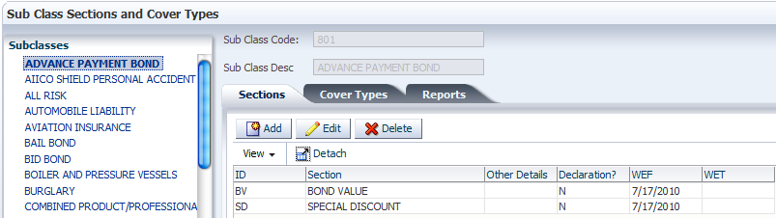
Subclasses are listed on the left pane and the tabs on the pane to the right show the sections and cover types that have been attached to a selected subclass.
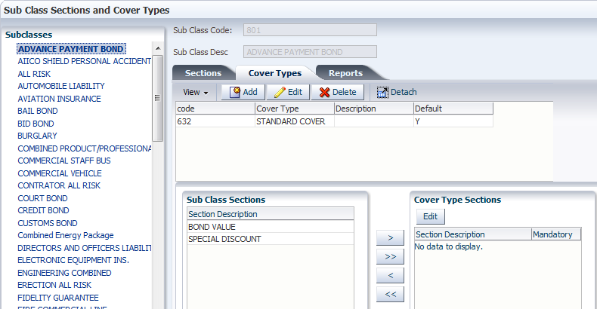
: Selecting an existing subclass lets you view the sections and cover types that have been attached to it.
- Click on the ‘Sections’ tab to bring up the ‘Choose Section’ dialog box.
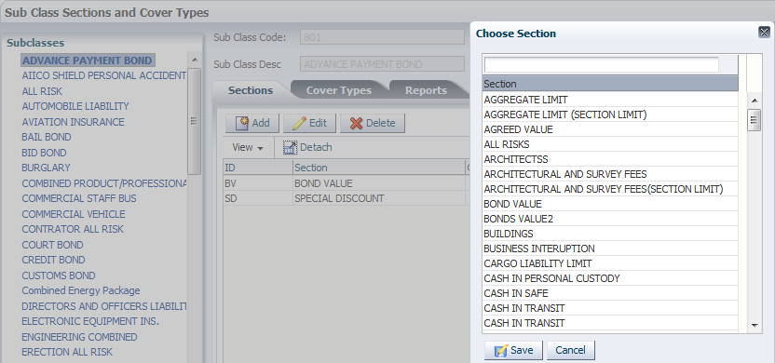
- Select a section on the list and click to add it to the list of sections under the selected subclass.
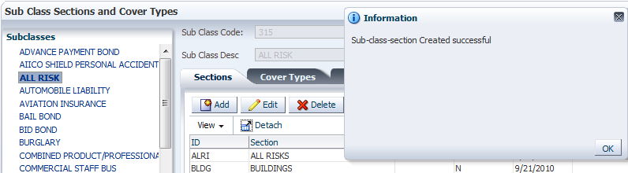
- Under the ‘Cover Types’ tab, click to bring up the ‘Add/Update Cover Type’ dialog box.
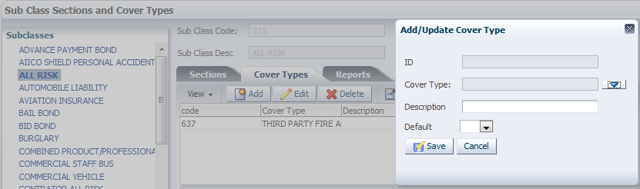
- The ‘ID’ field is auto populated with the ID of the selected cover type.
- The ‘Cover Type’ field shows the cover type that is selected. Click  to bring up a list of available cover types.
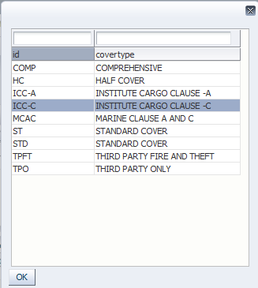
- Select one and click to populate the ‘Cover Type’ field in the ‘Add/Update Cover Type’ dialog box. The ‘ID’ field is also populated.
- The ‘Description’ field contains a short description of the cover type.
- The ‘Default’ field specifies whether the cover type is shown as the default whenever a cover type is to be chosen.
- Click to save the record.
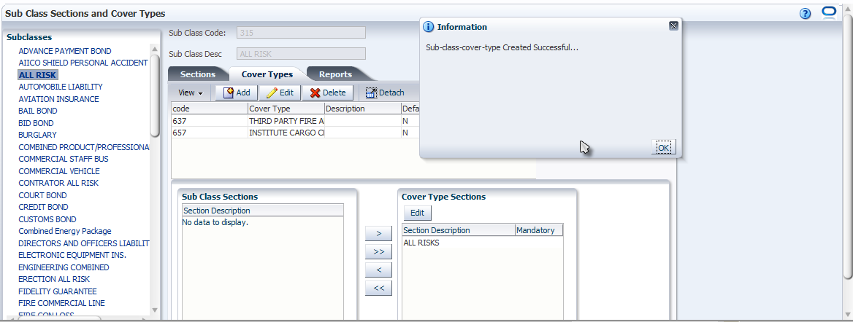
: Sections under the selected subclass should also be attached to the cover type selected from the list.
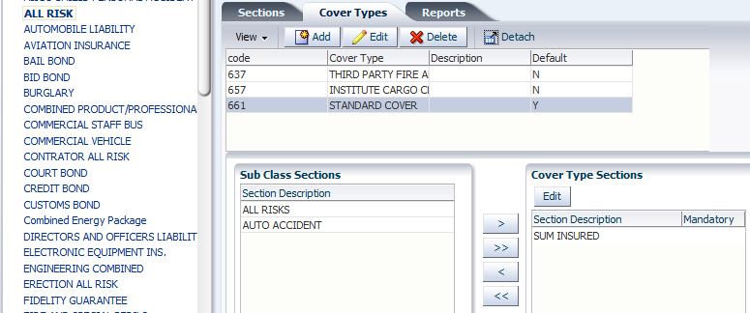
In the screenshot above, the ‘ALL RISK’ subclass is selected. On the ‘Cover Types’ tab, on the list of cover types, the ‘STANDARD COVER’ cover type is selected. Below the ‘Cover Types’ tab are two panes - ‘Sub Class Sections’ on the left and ‘Cover Type Sections’ to the right. The ‘Sub Class Sections’ pane shows the list of sections attached to the subclass and the ‘Cover Types Sections’ pane shows sections that have been attached to the selected cover type (‘STANDARD COVER’) under the same subclass.
- Click or 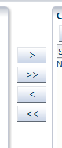 to move a single selected item. Click or to move all items back and forth between the two panes.

VEHICLE MAKES SETUP
Clicking the ‘Vehicle Make’ link in the ‘Cover Types and Sections’ section on the setup menu brings up the ‘Vehicles Make’ screen
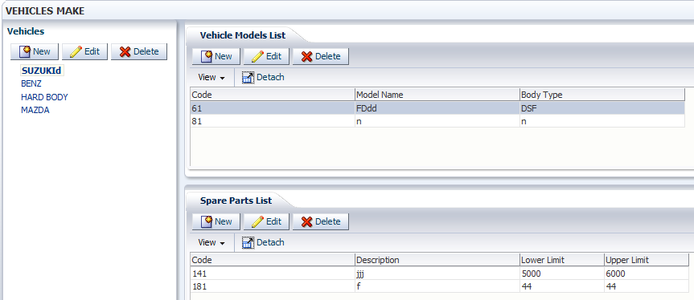
On the ‘Vehicles’ pane to the left, there is a list of existing vehicle makes in system. Selecting an item populates the screens to the right with more details. When a vehicle make is selected, the ‘Vehicles Model List’ pane is populated with a list of vehicle models of the make selected. Also, when a vehicle model is selected, the ‘Spare Parts List’ pane is populated with a list of spare parts for that model.

- Defining New Vehicle Makes
- Click on the ‘Vehicles’ pane to the left. This brings up the ‘Add Vehicle Make’ dialog box
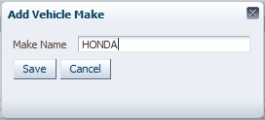
Specify the vehicle make name and click to save the new record

: To edit an existing vehicle make, select a vehicle make and then click. The ‘Add Vehicle Make’ dialog box is brought up again.
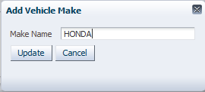
Change the name and click to save the edited record.

: To delete a vehicle make, click after selecting an item on the list of vehicle makes.
: A vehicle make that has models defined under it cannot be deleted until the models have been deleted. The same relationship holds between models and spare parts.
- Defining Models for a Vehicle Make
- Select the vehicle make for which models are to be defined and click on the ‘Vehicles’ pane to the right. This brings up the ‘Vehicle Model’ dialog box
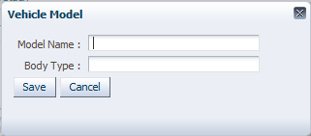
Specify the model name and body type and click to save the record.

: To edit a model, select a model and then click. This brings up the ‘Vehicle Model’ dialog box again.
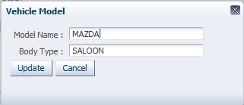
Edit the model name and body type and click to save the edited record.

- Defining Spare Parts for a Model
: The process is the same as that of vehicle makes and models.

PERILS AND TERRITORIES
- Defining a New Peril
- Click ‘Perils’ in the ‘Perils & Territories’ section on the setup menu. This brings up the ‘Perils’ screen.
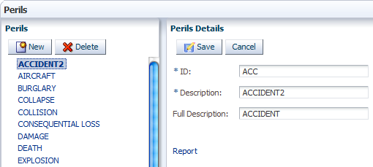
On the left, the ‘Perils’ pane shows a list of existing perils. Selecting an item on the ‘Perils’ pane populates the fields on the ‘Perils Details’ pane to the right showing the details of the selected peril.
- The ‘ID’ specifies a unique identifier for the peril.
- The ‘Description’ field specifies a descriptive name for the peril
- The ‘Full Description’ field contains a more elaborate description of the peril.
- Click to clear the fields on the ‘Perils Details’ pane.
- Fill in the details and click to create the new peril.

- Defining Territories
- Click ‘Territories’ under the ‘Perils & Territories’ section on the setup menu.
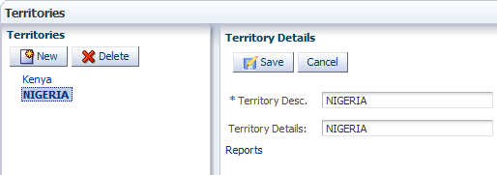
: The procedure is the same as defining perils described above.

- Defining Quake Zones
- Click ‘Quake Zones’ under the ‘Perils & Territories’ section on the setup menu.
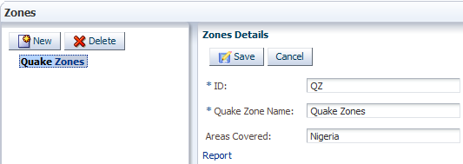
- The ‘ID’ field specifies the unique identifier for the zone.
- The ‘Quake Zone Name’ specifies the name to be given to the zone.
- The ‘Areas Covered’ field specifies the geographical region to be covered.

PREMIUM RATES SETUP
This setup has to be done to make sections (premium items) available for use at underwriting. The setup screens can be accessed from the ‘Premium Rates Setup’ section on the setup menu.
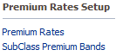

- Setting Up Premium Rates for Subclass Binders
- Click on the ‘Premium Rates’ link in the ‘Premium Rates Setup’ section on the setup menu. This brings up the ‘Premium Rates’ screen
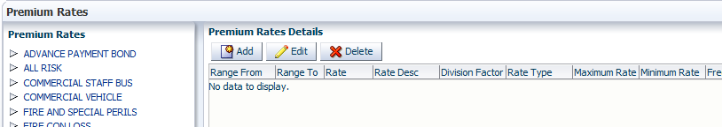
On the ‘Premium Rates’ pane to the left, there is a list of subclasses already created in the system.
Expanding the first item (subclass) by clicking the arrow reveals the second item (section or premium item).
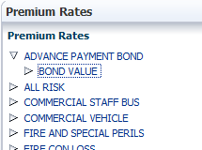
Expanding the 2nd item (section) by clicking the arrow reveals the 3rd item (binder).
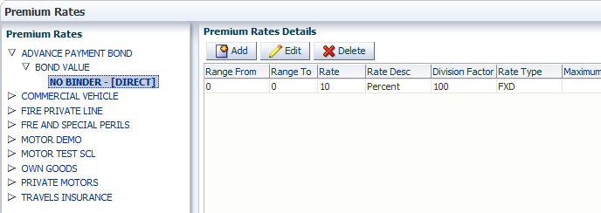
: Selecting the binder on the left pane shows the premium rate that has been set up on the ‘Premium Rates Details’ pane to the right.
- To set up a premium rate, click on the ‘Premium Rates Details’ pane. This brings up the ‘Premium Rates’ dialog box.
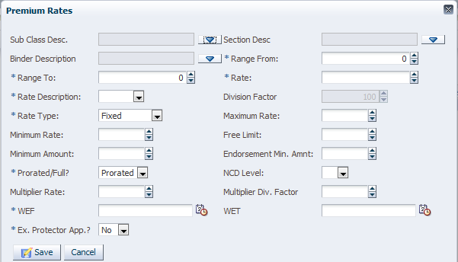
This captures all the parameters/factors that determine the premium computed, based on the sum insured inputted at underwriting.
- Click,, or type in text where appropriate to populate the various fields.
- The ‘Sub Class Desc’ (subclass description) field contains a short description of the subclass, selected from the ‘Select A Sub Class’ dialog box.
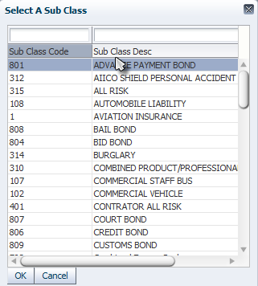
: This selection determines the subclass to which the binder will be attached. Select the required subclass and click to populate the ‘Sub Class Desc’ field.

- The ‘Section Desc.’ field contains the description of the section under the selected subclass, to which the premium mask will be attached.
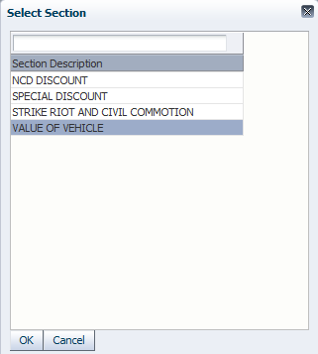
: The dialog box shows a list of sections that have been attached to the selected subclass at ‘Sub Class Sections and Cover Types’ setup. Select the required section and click to populate the ‘Section Desc’ field.

- The ‘Binder Description’ field
- The ‘Range From’ and ‘Range To’ fields specify a range of sum insured amounts within which the rate will be used if the ‘Range (Abs)’- Absolute or ‘Range (Step) range types is selected.
- The ‘Rate Description’ field specifies the division factor of the rate. For example, if the rate is 10 and the rate description is percent, the rate is then defined as 10 percent.
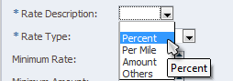
Percent: rate/100
Per Mille: rate/1000
Amount: Sum insure figure

- The ‘Rate’ field specifies a numerical value of the rate to be computed.
- The ‘Division Factor’ field shows the numerical value of the rate divisor specified in the ‘Rate Description field.
- The ‘Range Type’ field specifies how the rate specified is to be applied
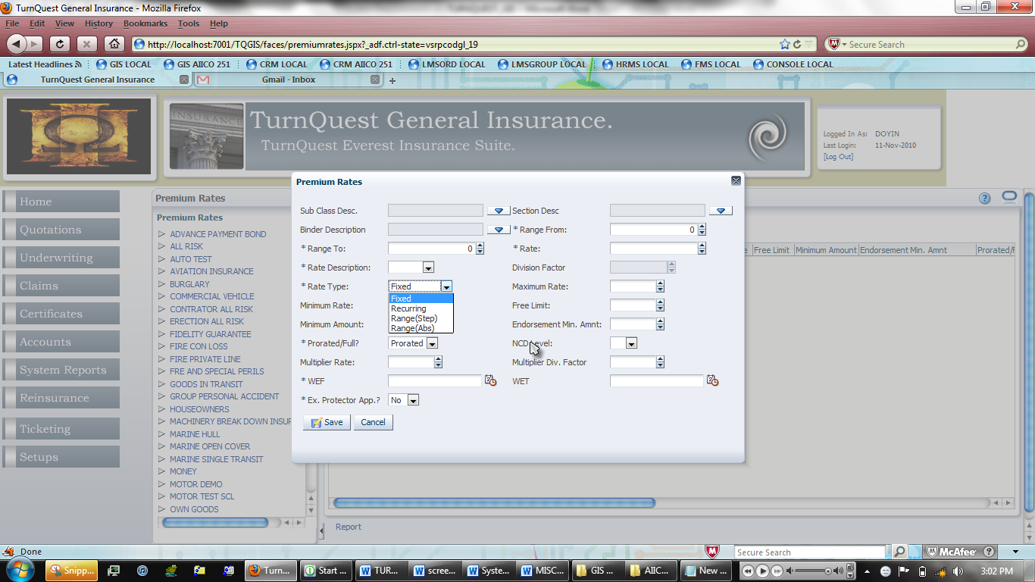
Fixed: Based only on rate and divisor
Range (Step): Based on the sum insured range specified in the ‘Range From’ and ‘Range To’ fields. e.g. 10/= for the first 1000, 7.50/= for the next 5000 and 5% for the rest.
Range (Abs): e.g. 10/= between 0-500, 15 between 501 and 1000, 17.50/= for anything over 1001/=

- The ‘Maximum Rate’ and ‘Minimum Rate’ fields specify maximum and minimum rates respectively
- The ‘Prorated/Full’ field specifies whether the premium to be calculated will be prorated based on the cover period. Click and select ‘Prorated’ or ‘Full’.
- The ‘NCD Level’ field specifies the ‘no claims discount’ level (in terms of years) that the rate will be applied to if the subclass is set up to allow NCD. Click and select a number from the drop-down list
- The ‘Multiplier Rate’ field specifies a multiplier for the rate being set up.
- The ‘Multiplier Div. Factor’ field specifies the division factor or the multiplier rate.
- The ‘WEF’ and ‘WET’ fields specify dates for the period within which the rate is valid and active for use.

- Click to save the premium rate.
: To edit a premium rate already set up, select the rate and then click to bring up the ‘Premium Rates’ dialog box. Click after entering details to save the edited premium rate. To delete a set up premium rate, select it and click.

- Defining Subclass Premium Bands
- Click on the ‘SubClass Premium Bands’ link in the ‘Premium Rates Setup’ section on the setup menu. This brings up the ‘Sub Class Premium Mask’ screen.
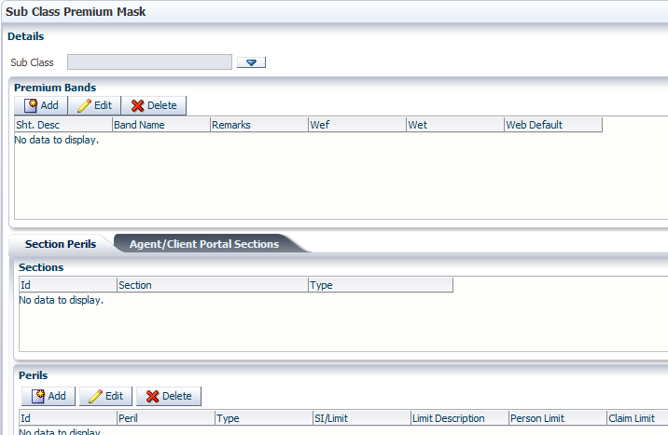
- Click to bring up the dialog box to select a subclass and populate the ‘Sub Class’ field

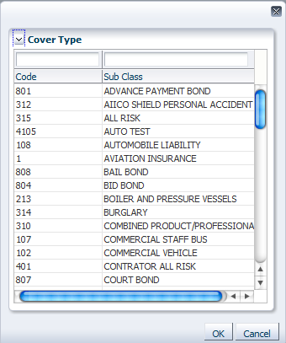
Select a subclass and click to populate the field.

The ‘Premium Bands’ pane is populated with the binder that has been attached to the selected subclass.
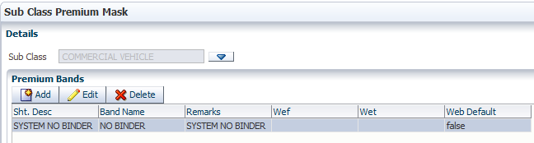
- Click to add a binder. This brings up the ‘Add/Edit Premium Bands’ dialog box
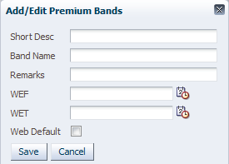
- Click to save the binder.
The pane below the ‘Premium Bands’ pane has two tabs- The ‘Section Perils’ tab and the ‘Agent/Client Portal Sections’ tab.
The ‘Section Perils’ displays the list of sections that have been attached to the subclass
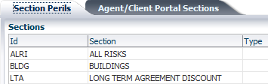

The ‘Agent/Client Portal Sections’ tab displays the list of cover types that have been attached to the subclass.
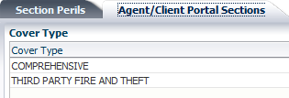
- To add a peril to the selected subclass, select a section ‘Section Perils’ tab and click on the ‘Peril’ pane below the pane that holds the ‘Section Perils’ tab. This brings up the ‘Add/Edit Perils’ dialog box.
: The lowest pane becomes the ‘Peril’ pane when the ‘Section Perils’ tab is selected
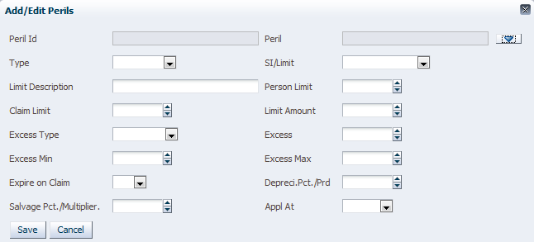
- Peril Id: System-generated identifier for the peril
- Peril: The peril selected from the list of perils added at the ‘Perils & Territories’ setup
- Click to bring up the dialog box with a list of perils set up in the system. Select a peril and click to populate the ‘Peril’ field.
- To populate the ‘Type’ field, click and select ‘Self’, ‘Third Party’ or ‘Both’ to define which party is covered against the peril
- To populate the ‘SI/Limit’ field, click and select the type of section that the peril applies to.

